No kids will be shipped by airline. On farm pick up or transport only.
There is generally a transport coming east in May. If interested in a kid to come east, call or text Helen Snyder at 717-979-6044 or email helen@starfirenubians.com.
Doe | Buck | Due | Available
Shauna(Tomato) | AI Oracle | 4-27 | NA
Louise | Sam | 4-4 | 3B
Pheonix | AI Oracle | 4-29
Linda | AI Mohave | 5-31
Cats Meow | AI Oracle | 4-10 | 3B
Polly C Holder | AI Mohave | 5-18
Dropper | AI Rockin-CB KR Hoku | 3-29 | 1 B
Lookie Lou | AI Rockin-CB KR Hoku | 4-26 | 2 B
Gospel | Red | 5-26
Pleasant
Tazo | Red
Kendra | AI Quantum Leap | 4-30 | 3 B
Quianna
Sadie
Snooks
Plain Jane
Sassy
Lottie |  | 5-23
Bianca
 | GRADES
Shameless
Rsstretto
Banana Parfait
Shamus | Red | 4-11 | NA
Pecan | Entendre | 4-25 | NA
Remorse | Red | 5-9 | 1 D

FOR SALE

LONE THISTLE SO SAM $500
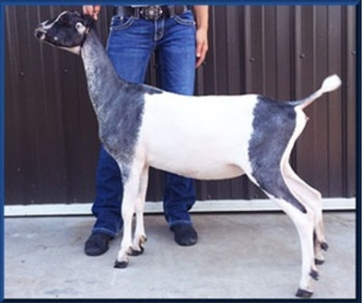
dam: MINT*LEAF SAVVY Spotlight Sale Doe
Picture from Mint*Leaf LaManchas
SS: ++*B SGCH BARNOWL GANDALF AL1427025 7 04-00 91 EEE
S: +*B LONE THISTLE ORACLE **DNA** AL1552520 03-04 89 VEV
DS: SGCH BARNOWL ABRACADABRA 2*M AL1368516 05-02 91 EEEE
LONE THISTLE SO SAM **DNA** AL1979231
DS: +*B SHAMMYS TU SENTINEL L1370463
D: MINT*LEAF SAVVY **DNA** L1787666 Spotlight Sale Doe
DD: CH MINT*LEAF CHEER L1504845

There are also a couple of adult LaMancha and Grade LaManchas does, for sale. Some open, some bred. $500 each

